MCQs Solutions

Q1. Which one of the following units is not a derived unit?
A. pascal B. kilogram C. newton D. watt
Q2. Amount of a substance in terms of numbers is measured in:
A. gram B. kilogram C. newton D. mole
Q3. The number of significant figures in 0.00650 s are:
A. 2 B. 3 C. 5 D. 6
Q4. Which of the following numbers show 4 significant digits?
A. 9000.8 B. 4 C. 5174.00 D. 0.001248
Q5. Which of the following prefixes represents the largest value?
A. mega B. pico C. peta D. kilo
Q6. A micrometer can be used to measure:
A. current B. force C. length D. mass
Q7. The instrument that best measures the internal diameter of a pipe is:
A. screw gauge B. vernier caliper C. metre rule D. measuring tape
Q8. The least count of a screw gauge is 0.01 mm. If its main-scale reading is zero and the third line of the circular scale coincides with the datum line, the measured thickness is:
A. 0 mm B. 3 mm C. 0.03 mm D. 0.3 mm
Q9. 9.483 × 10³ m in standard form is:
A. 94.83 m B. 9.483 m C. 948.3 m D. 9483 m
Q10. Which of the following is a base unit?
A. pascal B. coulomb C. metre per second D. mole
Q11. The number having one significant digit is:
A. 1.1 B. 6.0 C. 7.1 D. 6 × 10²

Q12. The ratio of millimetre to micrometre is:
A. 1000 m B. 0.001 m C. 1000 D. 0.001
Q13. 0.2 mm in units of metres is:
A. 0.0002 m B. 2 × 10⁻⁴ m C. both A and B D. none

Short Questions Answers

Q1. How does physics play an important role in our life?
Ans. Physics helps us understand how things move, how electricity works and why objects fall. It is the science behind everyday technologies like phones, cars, lights and even how we cook food.
Q2. Estimate your age in minutes and seconds.
Ans. If I am 14 years old:
- Minutes ≈ 14 years × 365 days × 24 hours × 60 minutes = 7 370 400 minutes
- Seconds ≈ 7 370 400 minutes × 60 sec = 442 224 000 seconds
Q3. What base quantities are involved in the derived quantities force, pressure, power and charge?
Ans.
- Force uses mass (kg), length (m) and time (s).
- Pressure uses mass (kg), length (m) and time (s).
- Power uses mass (kg), length (m) and time (s).
- Electric charge uses electric current (A) and time (s).
Q4. Show that the prefix “micro” is a thousand times smaller than prefix “milli.”
Ans. “Milli” means one thousandth (10⁻³) and “micro” means one millionth (10⁻⁶). Dividing: 10⁻³ / 10⁻⁶ = 10³, so micro is 1000 times smaller than milli.
Q5. Justify that displacement is a vector quantity while energy is a scalar quantity.
Ans. Displacement has magnitude, unit and a direction (e.g. 5 m north), so it is a vector. Energy only has a magnitude and unit (e.g. 20 J) and no direction, so it is a scalar.
Q6. Explain briefly why a screw gauge can give more precise length than vernier calipers.
Ans. A screw gauge has a very fine thread that moves the thimble in tiny steps (small least count), so it measures smaller differences more precisely than a vernier caliper as the screw gauge has a smaller least count than vernier caliper.
Q7. Differentiate between a mechanical stopwatch and a digital stopwatch.
Ans. A mechanical stopwatch uses gears and springs and shows time with hands. A digital stopwatch uses electronics and shows time on a screen in numbers.
Q8. How is a measuring cylinder used to find the volume of an irregular-shaped stone?
Ans. Fill the measuring cylinder with water and note the level. Gently drop the stone in and note the new level. The difference between the two levels is the change in volume and that is the stone’s volume.
Q9. What precaution should be kept in mind when using a measuring cylinder?
Ans. Always read the bottom of the meniscus (the curved water surface) at eye level to get an accurate measurement.
Q10. Why must we consider significant digits in measurements?
Ans. Significant digits tell us how precise a measurement is and help avoid false accuracy when we record or calculate results.
Q11. How can random error be reduced?
Ans. Repeat the measurement several times and take the average to reduce random errors.
Q12. Differentiate between precision and accuracy.
Ans. Precision means getting almost the same result again and again (consistency). Accuracy means getting a result that is close to the true or accepted value.

Long Questions Answers

Q1. Define physics and describe its revolutionary role in technology.
Ans. Physics is the study of matter, energy and how they interact. It gave us discoveries like electricity, magnetism and light that led to inventions such as electric lights, radios, computers and smartphones. Without physics, we wouldn’t have cars, airplanes, medical X-rays or the internet.

Q2. List and briefly describe the different branches of physics.
Ans.
- Mechanics: Studies how objects move and the forces on them.
- Thermodynamics: Explores heat, temperature and energy changes.
- Electromagnetism: Deals with electric and magnetic fields and their effects.
- Optics: Focuses on light, lenses and vision.
- Modern Physics: Includes relativity (very fast or heavy objects) and quantum physics (tiny particles).
Q3. What are physical quantities? Distinguish between base physical quantities and derived physical quantities. Give at least three examples to show that derived physical quantities are derived from base physical quantities.
Ans. Physical quantities are things we can measure, like length or time.
- Base quantities are the basic ones chosen by convention (e.g. mass, length, time, electric current).
- Derived quantities are combinations of base quantities (e.g. speed = length ÷ time, force = mass × acceleration, pressure = force ÷ area).
Q4. What do you mean by unit of a physical quantity? Define base units and derived units.
Ans. A unit is a standard amount we use to measure a quantity.
- Base units are the seven fundamental measures (kilogram for mass, meter for length, second for time, ampere for current, kelvin for temperature, mole for amount of substance, candela for light intensity).
- Derived units come from combining base units (e.g. newton = kg·m/s², joule = N·m, watt = J/s).
Q5. What are prefixes? What is their use in measurements?
Ans. Prefixes are letters we add before units to make them bigger or smaller. For example, “kilo-” (k) means 1 000 times and “milli-” (m) means 1/1 000. They help us write very big or very small measurements neatly, like 5 km instead of 5 000 m or 200 mg instead of 0.0002 g.

Q6. What is scientific notation or standard form of noting down a measurement? Give at least five examples.
Ans. Scientific notation writes numbers as a decimal times a power of ten, which is handy for very big or small values. Examples:
- 1 234 m = 1.234 × 10³ m
- 0.00023 s = 2.3 × 10⁻⁴ s
- 5 600 kg = 5.6 × 10³ kg
- 0.00000045 A = 4.5 × 10⁻⁷ A
- 9800000 J = 9.8 × 10⁶ J

Q7. Describe the construction and working of vernier callipers in detail.
Ans. VERNIER CALLIPER:
Construction:
A vernier caliper has two sets of jaws and two scales: the main scale (fixed) and the vernier scale (sliding).
Working:
To measure an object, you place it between the jaws, slide the vernier scale until it fits snugly and then read the main-scale value plus the matching vernier division. The smallest difference you can read (least count) is the main-scale division minus one vernier division (usually 0.1mm).

Q8. What is a screw gauge? What is its pitch and least count? How is it used to measure the thickness of thin copper wire?
Ans. SCREW GAUGE:
Construction:
A screw gauge (micrometer) has a U-shaped frame, anvil, spindle and a thimble with a scale.
The pitch is how far the spindle moves per one turn (e.g. 0.5 mm per rotation).
The least count is pitch ÷ number of thimble divisions (e.g. 0.5 mm ÷ 50 = 0.01 mm).
Working:
To measure a wire, you place it between anvil and spindle, turn the thimble until snug, then add the main-scale reading to the thimble reading for the total thickness.

Q9. Define error. Differentiate between random and systematic error. How can these errors be reduced?
Ans. An error is the difference between a measured value and the true value.
- Random errors vary unpredictably (e.g. tiny hand movements) and can be reduced by repeating measurements and averaging.
- Systematic errors are constant biases (e.g. a mis-zeroed scale) and can be reduced by calibration or using better instruments.
Q10. Differentiate between scalars and vectors. Justify that distance, speed, mass and energy are scalars while displacement, velocity, acceleration and force are vectors.
Ans. Scalars have only magnitude (size) and unit, vectors have magnitude, unit and direction.
- Scalars: distance (5 m walked), speed (10 m/s), mass (2 kg), energy (20 J) need no direction.
- Vectors: displacement (5 m north), velocity (10 m/s east), acceleration (2 m/s² upward), force (5 N downward) all include direction.
Q11. Justify and illustrate the use of a measuring cylinder to measure the volume of a liquid.
Ans. A measuring cylinder is a tall, narrow tube marked with volume lines. You pour the liquid into it and read the bottom of the meniscus (curved surface) at eye level to get an accurate volume. Its narrow shape and fine scale markings make it more precise than beakers.

Q12. Differentiate between precision and accuracy.
Ans.
- Precision means how close repeated measurements are to each other (e.g. 5.1 cm, 5.0 cm, 5.1 cm).
- Accuracy means how close a measurement is to the true value (e.g. measuring a 5 cm length as 5.0 cm is accurate).
You can be precise but not accurate if you get the same wrong result every time.

Numericals Answers

Q1. Write the following numbers in scientific notation:
a. 1234 m
b. 0.000023 s
c. 469.3 × 10⁵ m
d. 0.00985 × 10⁷ s
Ans.
a. 1234 m = 1.234 × 10³ m
b. 0.000023 s = 2.3 × 10⁻⁵ s
c. 469.3 × 10⁵ m = 4.693 × 10⁷ m
d. 0.00985 × 10⁷ s = 9.85 × 10⁴ s
Q2. Express the following measurements using SI prefixes:
a. 27.5 × 10⁻¹⁰ m
b. 0.00023 × 10⁻² s
Ans.
a. 27.5 × 10⁻¹⁰ m = 2.75 × 10⁻⁹ m = 2.75 nm (nanometres)
b. 0.00023 × 10⁻² s = 0.0000023 s = 2.3 × 10⁻⁶ s = 2.3 µs (microseconds)
Q3. If a boy is 15 years, 2 months and 10 days old, convert his age into:
a. seconds b. milliseconds c. megaseconds
Ans.
- Total days = 15×365 + 2×30 + 10 = 5475 + 60 + 10 = 5545 days
- Seconds = 5545 d × 24 h/d × 3600 s/h = 5545×86400 = 479 088 000 s ≈ 4.79 × 10⁸ s
- Milliseconds = 4.79 × 10⁸ s × 1000 = 4.79 × 10¹¹ ms
- Megaseconds = 4.79 × 10⁸ s ÷ 10⁶ = 4.79 × 10² Ms (≈ 479 Ms)
Q4. How many kilometres are there in 25 micrometres?
Ans.
- 25 µm = 25 × 10⁻⁶ m = 2.5 × 10⁻⁵ m
- In kilometres: 2.5 × 10⁻⁵ m ÷ 10³ = 2.5 × 10⁻⁸ km
Q5. What is the pitch and least count of:
a. Vernier calipers with main scale division of 1 mm and 20 vernier divisions?
b. Screw gauge with main scale division of 0.5 mm and 50 thimble divisions?
Ans.
a. Vernier
- Least count = (1 mm) ÷ (20) = 0.05 mm
- (Vernier has no “pitch.”)
b. Screw gauge
- Pitch = one main scale division = 0.5 mm
- Least count = pitch ÷ divisions = 0.5 mm ÷ 50 = 0.01 mm

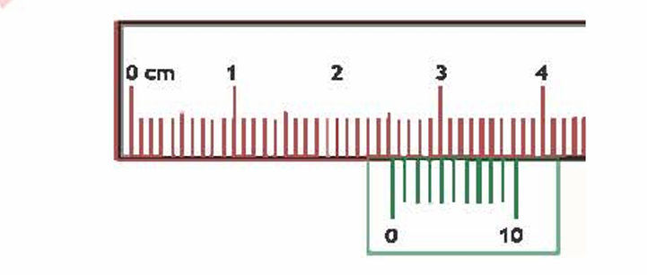
Q6. Vernier caliper measurement (see diagram):
a. Main‐scale reading = 3.00 cm
b. Coinciding vernier division = 7
c. Total reading = 3.00 cm + (7 × 0.01 cm) = 3.07 cm
Q7. Screw‐gauge measurement (see diagram):
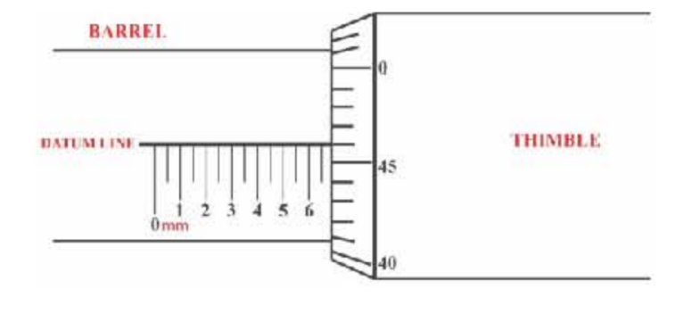
a. Main‐scale reading = 6.00 mm
b. Coinciding thimble division = 45
c. Total diameter = 6.00 mm + (45 × 0.01 mm) = 6.45 mm

